Discussion Groups

What will we be doing in the Kingdom?

Kingdom Conference 2020

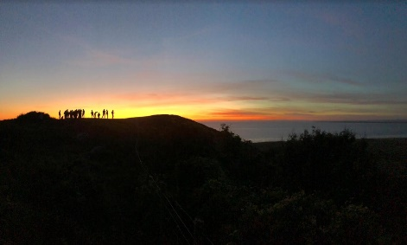
Discussion Group 4: What will we be doing in the Kingdom?

‘they lived and reigned with Christ a thousand years’
What passages show that there will be a temple and sacrifice?

What will the mortals be doing and how often will they visit Jerusalem?

What will the hierarchy be in the Kingdom?

What will it mean to be kings and reign with Christ?

An important part of being a priest is teaching. How will we fulfil this role?

What powers will we have and how will they help us to fulfil our roles?
Will we still need to learn new things?

How can we now prepare for our role in the future?

Bonus questions
When will we eat? When will we sing? What will we do at ‘night’?

Any other questions about our role in the Kingdom you would like to discuss?

